**IT2120 - Probability and Statistics** LabSheet 05  
  
1. Import the dataset (’Exercise – Lab 05.txt’) into R and store it in a data frame called ”Delivery Times”.

2. Draw a histogram for deliver times using nine class intervals where the lower limit is 20 and upper limit is 70. Use right open intervals.

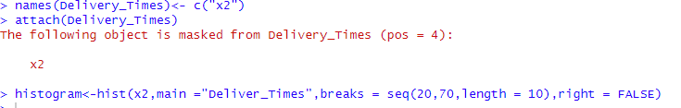

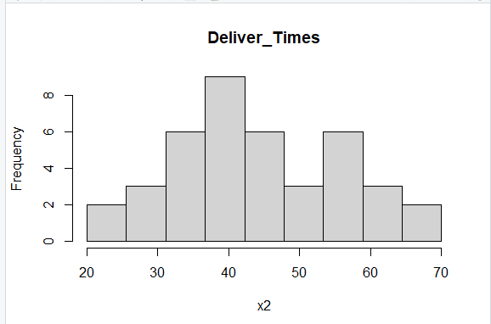

3. Comment on the shape of the distribution.

The distribution of delivery times appears to be approximately symmetric and bell-shaped, with a peak around the 40–45 interval. This suggests that:

* Most delivery times are clustered near the center.
* Frequencies taper off evenly on both sides of the peak.
* There is no significant skewness—neither left nor right.

4. Draw a cumulative frequency polygon (ogive) for the data in a separate plot



